Name of Candidate : RAJENDRAN SUBASH

FIN I / C Number : M3280825L

Contact Number : +65-96423847

Email-id : sudashrajendran77@gmail.com

Batch No : 26-209

Name of Module : WSH Incident Management

Number of Pages : 17

Name of Trainer :

Name of Assessor : Mr. Vijay Anand

Date of Submission : 19/06/2024

*I declare that I am sole author of this assignment and that no parts of this assignment have been taken or lifted from other sources. All of this assignment is original.*

*I understand that, if any plagiarism is found in the assignment may lead to disqualification from the course.*

*Signature /Date*

For Official Use Only

Assessor Signature _____________________



Q1.Composition of Incident Investigation Team and Outline Duties and Responsibilities of 3 Members.

Project Manager

MR. GK Santhosh

HP:

86505855

Incident Commander

WSH Officer

MR. Abdul hazin

HP: 98530747

Assembly Area Coordinator

Site Supervisor

MR

. Jayarajan

HP: 81391529

Staging Area Commander

WSH Coordinator

MR. Vaithe

HP: 93505957

Assembly Area Coordinator

Fire Fighting Team

MR. Win

First Aider

MR

. Karuppiya

Emergency Team

MR, Muruge

san

Project manager:-

After accident WSH Officer immediately informs to manager if minor First Aid then major send to hospital or call 995. Project manager or his representative shall instruct the WSH Officer to investigate the accident. The project manager should facilitate the investigation by appointing a liaison to work closely with the authorities in gathering information and evidences need for investigation. The investigation should be conducted as soon as possible after an accident, because the evidence may deteriorate or change rapidly.

WSH OFFICER:-

The WSH officer together with the safety personal may visit the scene of the incident and then instruct the injured workers supervisor to investigate the incident and submit a report on it within 24 hours of the accident. The WSH officer together with the assistance of the safety personal shall conduct a preliminary investigation on the case and notify the project manager describing to him verbally on the accident and indicating to him the possible causes of the accident. Of the accident. The incident if falls under the classification of reportable accident shall be reported to MOM through i- report.

# FIRST AIDER:-

Workplace happen any injury safety personal must inform to First Aider then first aider immediately informs to WSHO

Recognizes and identifies the need of calling ambulance for treatment by n general practitioners. Lead the investigation team into the incident scene. Don’t allow to take photo by authority to upkeep and maintain records on all accidents resulting in injuries to personal. Attends safety meeting and prepare first aid statistics for target setting and replenish and maintain stock on first aid medicines.

Q2.Evidences (at least 3) gathered including physical evidence and interview witnesses.

Type of evidence:

Photo and video footage of the incident scene.

Statement from those involved in the incident document.

|  |
| --- |
| INJURY PLACE & WORKER PHOTO |
|  |

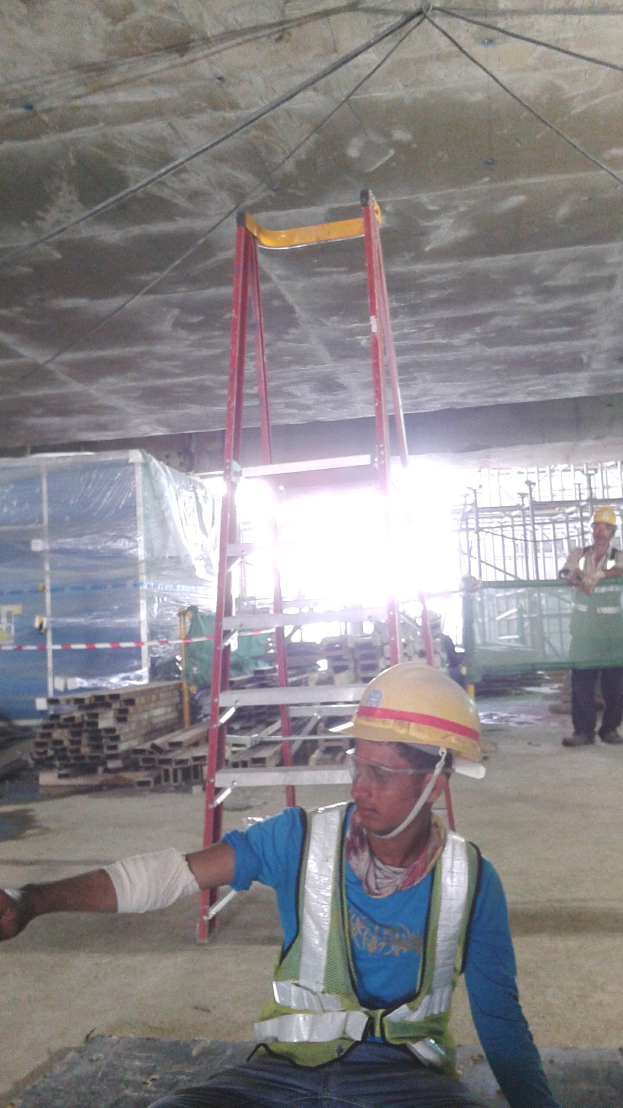

INCIDENT REPORTING FORM

Date of Notification: 20-05-2021

Company: SL PTE LTD

Reported By: MR: RAJA (G8752856T) Signature ------------------.

Supervisor: MR. KARUPIYA

Witness: MR. MURUGESAN

1. PARTICULARS OF WORKER

|  |
| --- |
| Name : Mohamad Islam |
| NRIC/Passport No :G6324581P Work Permit No.: 063478195 |
| Nationality: INDIAN Race: MUSLIM Sex: Male |
| Date Of Birth: 25/01/1995 Marital Status : UNMARRIED |
| (Address & Telephone No.): SL PTE LTD  3018 Thomson rd. S778511 |
| TEL: 6845-5419, Fax: 65486723, Website: www.slain.com.sg |
| Occupation : General worker |

1. PARTICULARS OF INCIDENT / ACCIDENT

|  |
| --- |
| Project/Worksite: N-106 |
| Date : 20-05-2021 Exit Location of work : TN Subway slab |
| Nature Of Injury (in details): twisted & cut calf. |
| Description Of Machine Involved (if any): N/A |

1. BRIEF DESCRIPTION OF INCIDENT / ACCIDENT

## (Describe how the incident / accident happen, provide sketches where applicable)

On 20 MAY 2021 to one of our company SL PTE LTD (UEN NO: T77G2145440X) Indian general worker Mr. Mohamed Islam (NRIC NO: G6324581P) at 11.20 pm. The employee Mr. Mohamed Islam was carrying out electrical work, he was standing on the A frame Ladder 2m height from the ground level. When this worker during electrical job suddenly he fell down on the floor and injured his right hand calf. SL safety given to him first-aid and immediately send him to Riffles hospital and Doctor Mr. Kong he hwah was given to him 5 stitches and 2 days medical leave. (MC 20-05-2021 To 22-052021)

4) OTHER INFORMATION

|  |
| --- |
| Name Of Clinic/Hospital Where Worker Received. |
| Raffles Hospital |

### 5) INVESTIGATION/FOLLOW-UP ACTIONS

Possible Causes/Contributing Factors (please tick [  ] where applicable

|  |  |  |
| --- | --- | --- |
| PRIMARY CAUSES | | |
| SUB-STANDARD PRACTICES:  [ ] Unauthorised operation  [ ] Speeding  [ ] Used defective equipment/tools  [ ] Used tools, equipment, vehicles or material unsafely  [ ] Did not use PPE  [ ] Improper use of PPE  [ ] Taking unsafe position/unsafe act  [ ] Unsafe act by another person  [ ] Making safety devices inoperative or unsafe  [ ] Unsafe loading, placing or mixing  [ ] Unsafe lifting, carrying - Manual lifting.  [ ] Riding on loads, forklifts or other lifting equipment  [ ] Improper work method | | SUB-STANDARD CONDITIONS:  [ ] Inadequate guards/absence of guards  [ ] Poor quality of PPE  [ ] No/inadequate working platform  [ ] Poor housekeeping  [ ] Hazardous machine, tool or equipment  [ ] Improper storage/stacking of material  [ ] Absence of/inadequate barricades  [ ] Faulty electrical installation  [ ] Unsafe place of work  [ ] Inadequate/congested area  [ ] Inadequate warning system  [ ] Explosion hazard  [ ] Reactive chemicals  [ ] Hazardous atmosphere  [ ] Unsafe lifting  [ ] Inadequate ventilation |
|  | [ ] Malfunction or defect in machine, tools or equipment  [ ] Tripping/slipping hazard | |

Q3. Incident evidence analysis and evaluation – root cause analysis.

|  |  |
| --- | --- |
| ROOT CAUSES | MANAGEMENT SYSTEM FAILURE |
| HUMAN FACTORS  [ ] Physical incapacity  [ ] Mental incapacity  [ ] Lack of knowledge  [ ] Lack of skill/experience  [ ] Physical stress/strain  [ ] Psychological stress  [ ] Language difficulty  [ ] Lack of coordination  [ ] Horseplay  [ ] Under drug/alcohol influence  WORK FACTORS  [ ] Inadequate leadership/supervision  [ ] Inadequate engineering  [ ] Improper tools/equipment/materials  [ ] Inadequate work standard  [ ] Abuse or misuse | [ ] Safety policy & delegation  [ ] Safe work practices  [ ] Safety training  [ ] Group meeting  [ ] Incident investigation  [ ] In-house rules & regulations  [ ] Safety promotion  [ ] Control of contractors  [ ] Safety Inspection  [ ] Maintenance regime  [ ] Hazard analysis  [ ] Control of hazardous chemicals  [ ] Emergency preparedness  [ ] Occupation & Health  [ ] Security & Loss Prevention |
|  |  |

Distribution List:

1. Project Manager / Chairman (WSH Committee).
2. Safety Manager / Safety Officer / Safety coodinator
3. Senior Construction Manager / Construction Manager.

ROOT CAUSE;

* + - Lack of coordination among the from work electrical team
    - No close supervision during the from work electrical
    - Lack of skill

Incident analysis and evaluation – root cause analysis:

FISHBONE DIAGRAMS:-

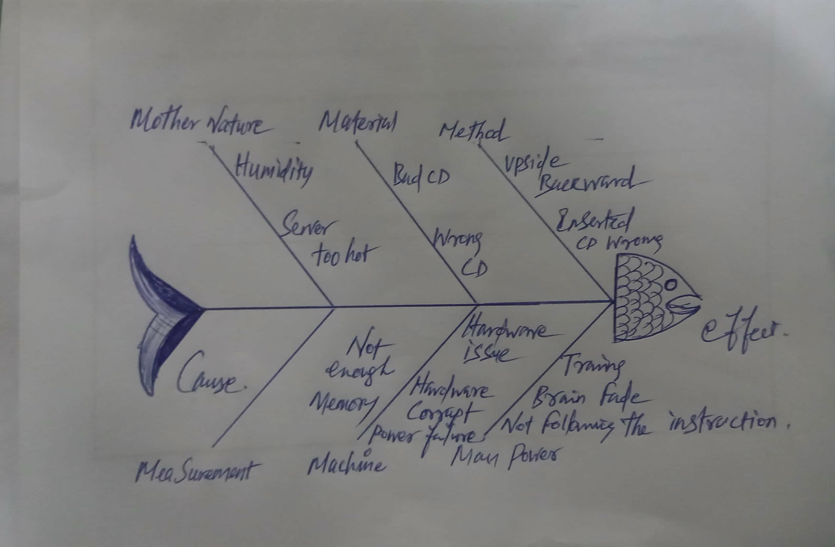

|  |  |  |
| --- | --- | --- |
| 01 | Man | * Inadequate supervision * In competent personnel |
| 02 | Methods | * Lack of Training * fail to conduct RA/SWP |
| 03 | Materials | - Safety harness to wear and anchor |
| 04 | Environment | - Uneven Grounds |
| 05 | Measurements | - Fail to Conduct RA / SWP |

Recommendation:

Fish bone analysis was adopted to analyze the root cause of the accidents.

Based on the fish bone diagram, the following were recommended.

* + To brief all employees and contractors on hazards of unsecured and temporary structure before commencing any job
  + To obtain permission before entering the worksite or before commencing the investigation.
  + Before work commences, carry out an inspection to identify any hazard on site.
  + Use appropriate equipment and machinery whenever potential hazard of falling objects exists.
  + Review risk assessment for the sad activity.

Q4. Corrective and Preventive Measures.(at least 2)

Hierarchy of control measures:

1) The hierarchy of control is a sequence of options which offers you a number of ways to approach the hazard control process.

* + - Elimination
    - Substitution
    - Engineering control
    - Administrative control
    - Personal protective equipment

Corrective Actions:

* + - Incident area provide guardrail.
    - Attention work.
    - Provided good proper working platform.

Preventive Measures:

* + - Two person good coordination electrical working time.
    - Closed monitoring by supervisor.
    - Use the scissor lift up to electrical work.
    - Immediately job stopped and given briefing to all workers regarding electrical working
    - Daily contact TBM pre start work.

Q5. Documentation (collation of information / documentds) and submit report to relevant parties and government agencies.

General information:

Notification Reference No: SL/C944/16 Submit Type: Online

Notification Type: Work related accident Informant Type: Employer Received Date: 20 MAY 21 Informant Name: Mohamed Islam

ID Type and Number:

Contact No: 83652144

Email address: mdlslam@gmail.com

### About your organization

Organization UEN: T77G2145777X Office No: 68455417

Organization Name: SL Pte Ltd Fax No: 65486723

Mailing Address: Punggol Drive Email Address: www.slain.com.sg

No. of employees: 530

About the accident

Date: 20/05/2021

Time: 11:30Hrs

Please describe how the accident happened:

The employee Mr. Mohamed Islam was carrying out Electrical work, he was standing on the A frame Ladder 2m height from the ground level. When this worker during electrical work suddenly he fell down on the floor and injured his right leg calf. SL safety given to him first-aid and immediately send him to hospital further treatments.

The accident happened at: Electrical Work

Address of accident site: Thomson Rd Type of incident: Twisted & cut

Type of equipment or agencies that lead to the accident: Electrical work. Was any person, including the employee injured in the accident? Yes

About the injured

Particulars of the injured person

ID type and No: G6324581P Employment details of injured person+

Name: Mohamed Islam

Occupation: General worker

Nationality: Indian Start Date of employment: 02 Jan 2018

Date of birth: 25/01/1995 Average monthly earnings: $1000

Gender: Male Percentage of manual work performed by

The injured person: More than 65%

Race: Muslim

Residential Address: 31 Woodlands, S737855

Contact No: 83652144

Details of injury other details

Did the accident result was the injured person

IN death of injured person? No hospitalized for at least 24 hours? No

What was the injury No of day’s medical leave given: 3 days

Suffered? Twisted & cut

Which part of the body Hospital/clinic where the injured person was

Was injured? Right Hand calf examined or treated: Raffles hospital

What time did the injured person start work on the day of the accident? 07:30am

Was the injured person working overtime when the accident happened? No

Was the person injured while performing official work duties? Yes Name of insurer: Ram life insurance pte ltd.

Insurance Policy No: SL2539-8061X

Q6.Monitor and report progress of corrective and preventive measures

.

* Stopped the work and conducted briefing to the all workforce on the incident and lesson learnt.
* Electrical work during time must follow RA, SWP.
* Gathering all information justify by project manager.
* Project manager see all particular of injury person.
* Follow the (SWP) and use appropriate P.P.E
* Implementation the proper supervision on site.
* Review Risk assessment for the sad activity.
* Supervisor closed monitoring work.
* Coordination meeting highlighted weakly safety inspection to conduct with all project team members
* Manager must check all particular of injured person

Monitor /close out report.

|  |  |  |  |  |  |  |
| --- | --- | --- | --- | --- | --- | --- |
| S/N | CAPA | Person in charge | Method | Period | Report submit | Remark |
| 1 | Implement ptw system | WSH  Officer | On going | Daily | Project manager / client |  |
| 2 | Use proper PPE | engineer | On going | daily | Project manager/ client |  |
| 3 | Close supervision work area | Site supervisor | On going | daily | Project manager/ client |  |

# Advance Certificate in WSH LEVEL B

|  |  |  |  |  |  |  |
| --- | --- | --- | --- | --- | --- | --- |
|  |  |  |  |  |  |  |
| 4 | Training provide to worker | Wsho | On going | daily | Project manager client |  |

Q7.Action Plan for Monitoring and Reporting Progress of Incident Costs.

|  |  |  |  |  |  |
| --- | --- | --- | --- | --- | --- |
| S/No |  | Possible costs involved in an incidents |  | Costs |  |
| 01 |  | Medical cost arising from injured work | ers | $ 500 | |
| 02 |  | Injury compensation to families |  | $NA | |
| 03 |  | Legal proceedings & Legal fees |  | $ NA | |

|  |  |  |  |  |  |  |
| --- | --- | --- | --- | --- | --- | --- |
| S/  N | Hazard | Prevent measure | Action by who | Time By when | Status | Remark |
| 1 | Work at height | Provide  Barricade Use full body harness/  Anchorage  Point/life line | Site supervisor/ Electrical supervisor | 02-04-2021 | 6 Days |  |
| 2 | Caught in Between | Manually carry time good  coordination  Follow RA/SWP | Safety/Electrical supervisor | 03-04-2021 | Immediat ely |  |
| 3 | Falling objects | Keep material  building  Edge  Toe board  Provided/  All worker  Must be trained | Safety/ Electrical supervisor | 05-04-2021 | 14 Days | Material  No  enough |

Action Plan costs

# Advance Certificate in WSH LEVEL B

|  |  |  |
| --- | --- | --- |
| 04 | Cost arising from damaged property | $ 1200 |
| 05 | Cost arising from damaged to structures | $ NA |
| 06 | Cost arising from damaged utilities | $ NA |
| 07 | Cost arising from damaged equipment | $ NA |
| 08 | Cost arising from a stop work order | $ NA |
| 09 | Salary to workers for stop work | $ NA |
|  | Total | $1700 |

*THANK TOU*….